Training not only enhances the knowledge but also added energy for behavior change.
Yagya Prasad Adhikari, a habitant of Sainamaina of Rupandehi district, has been working as in health sector in a position of Senior Auxiliary Health Worker (AHW) since 19 years in Kapilvastu. He started working as a health post In-charge of Khurhuriya HP of Bijayanagar Rural Municipality and now he is serving as Health Coordinator of Bijaynagar Rural Municipality in Kapilvastu. He is a simple, descent and helpful person. He is always ready to help people and do social work.
Being a health worker, Yagya Prasad Adhikari has participated in different kind of training, workshops & seminars during his service period. He also participated in two different Training of Trainers (TOT)- ' Health Facility Operation and Management Committee (HFOMC) as per new national model guideline and Neglected Tropical disease (NTDs)' organized by Essential Health project which is implemented by Kalika Self-Reliancce Social Centre in partnership with FAIRMED Foundation Nepal.
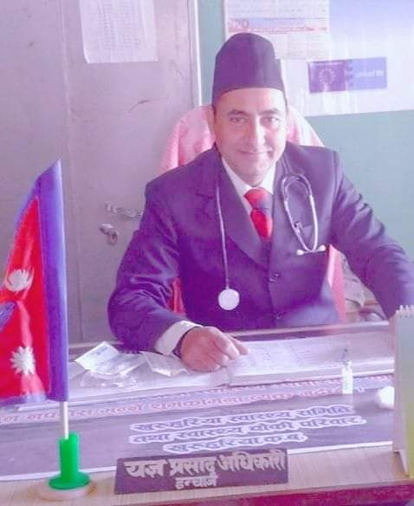
After taking training of HFOMC, he supported to endorse and approve the new national guideline of HFOMC as well as participated as trainer of capacity enhancement training of HFOMC of all five health facilities of Bijayanagar Rural Municipality. This training was also supported by EHP and YP Adhikari collaboratively worked with project team for empowering HFOMC members to improve the quality health services and health of community. He said,"Its my owner to help community. I have got different trainings but I feet good when I got pportunity to express and share my learning to people. I want to thank EHP team for providing me this opportunity'. Similarly, the TOT on NTDs has also brought some impact on his knowledge and behavior. He added, " We are regularly working for leprosy and being a health worker I also know many things about leprosy. But after participating in 5 days TOT on NTDs, I got a great opportunity to know many new things about leprosy and other diseases under NTDs. We used to thought after medication of leprosy patient is fit and required no follow up neither we followed up after RFT. This training tought us to consider the problem of affected people as well as community by being with them. The stigma hiding in community is a major cause to spread the disease. Now onwards I will work for identifying new cases as well as support affected people for self care to prevent disability. I will also plan for program for those affected people to make them self dependent from rural municipality. A great change observed on me is that now I suspect any kind of skin disease as leprosy which I think is important."
Knowledge can be gathered from any place. A well structured and specific package of knowledge with specific purpose can change the behavior of a person. A skilled person also required re-fresher training. The training of trainers on HFOMC & NTDs has worked as a change maker to enhance the skill of health worker as well as contributed in development of Health sector.

