Together is strength.
Suddhodhan RM is inhabitant of different community and ethnicity mainly this municipality have majority of people living in this community belongs from Muslim community and speaks Awadhi language. People living in this community depend on Agriculture. The people living in this community have given less priority on health education and child rights so that the people of the community were unknown about the facilities provided by the government.
In this community child marriage is one of the major problems. Government has also given less priority on this due to this there come so many problems like: health less education and also increase in criminal activities in the community.
Suddhodhan Rural municipality have 6 wards and develop 1/1 Adolescent and child network in all wards and 1 Municipality level network of Adolescent group to minimize and to reduce child marriage, reduce dwary system and domestic violence but that group was functionless.
In that 6 groups total 180 adolescent girls and boys. And in municipality level there were 30 adolescent members in municipality level. Mainly in this area especially girls were not allowed to go outside from their house So that they don’t have any idea what is happening outside or around the community. There was so many plan and opportunities provided by the government Like; Budget, adolescent rights, and other services provided from the health facility specially Adolescent friendly services but this group haven’t any ideas on this and the municipality also have given less priority on this types of issues.
KSSC-Nepal under Amplify Change has implemented the Girls Rights against Negative Traditions project from 1st February 2020 in Suddhodhan Rural Municipality. The main aim of this project is to ensure sexual and reproductive rights of adolescents and end of child marriage. This program has started its program through training, workshop to empower and encourage uplifting the adolescent groups and also regular advocacy with the municipality stakeholder on reproductive and child rights. Project also orient about the network and what network will do to fight against problems faced by the adolescent group.
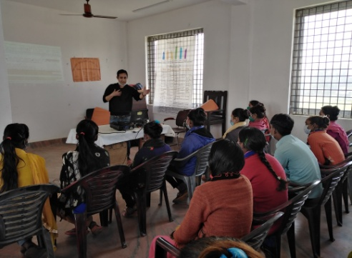
Project has support to develop different policies and constitutions on adolescent rights. Project also have regular advocacy with HFOMC and made realization to HFOMC members that the ASHR corner is very necessary to provide services to Adolescent groups.
Mainly the policy and constitute Helps adolescent group to find out the way and helps to fight against the negative tradition on child marriage and reproductive rights. after the training of Resource tapping and short proposal writing provided by the project the KSSC and members who were in Municipality level network have regular advocate with municipality and Suddhodhan Rural Municipality have allocated a budget of Rs. 200000. After the allocation of budget from Municipality the adolescent network of Municipality level have provided training to all 6 adolescent groups on child rights, sexual and reproductive health and rights and legal Procedure on child marriage.
Municipality chairperson has committed to provide Rs. 50000 in coming fiscal year and also have committed to end child Marriage. He also committed to provide all help and support which were needed to the adolescent group. Furthermore he have committed that he will follow the government rules and policies if anyone have done child marriage in his Municipality. All the adolescent groups were now active and they start talking on their rights in everywhere.
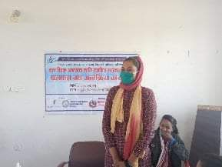
Babita tharu president of the saskta Adolescent Network Thank to KSSC- Nepal under amplifier change for providing such types of opportunities which helps them to fight against child marriage and adolescent rights. . The group members were well aware about their rights and start talking on this in every program and also participate and share their problems in Municipality level. She also said not only me but all the members start talking on child rights and also they have committed that they will continue this activity if KSSC under amplify change will not there but will expect back support from the organization in future.

