Sheskala, The Empowered Adolescent Girls.
Suddhodhan Municipality lies between Matyadevi RM west, Rupandehi in the east Banganga in the north and India boarder in the south. The people living in this community specially go neighbor country for income generation. In this municipality child Marriage is one of the major problems. So that to end this child marriage Suddhodhan Municipality have formed different adolescent network in ward level.
Likewise 1 adolescent network in municipality level. In that group there are 30 members. The group members were from the members who are in adolescent network which was formed in ward level. Seskala Pandey is one of the members of Ward level adolescent network of Suddhodhan ward no. 4 and she is the chairperson of Municipality level adolescent group.
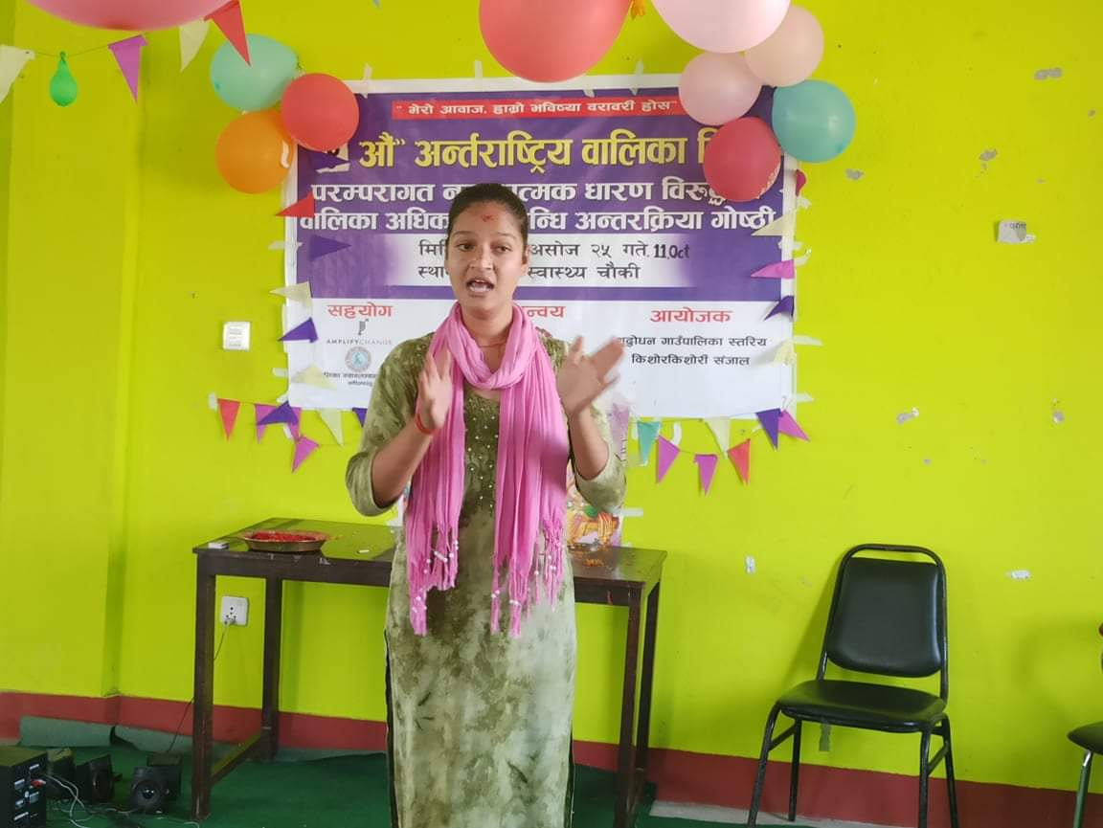
She has actively participated in all the training provided by KSSC/GRANT project. And after the training she starts advocacy against child marriage, child rights and ASRHR on Ward level and Municipality level. After the training she fells child marriage is one of the major issues and create many health problems in their life so that to reduce this she starts awareness raising campaign against child marriage, child rights and ASHRH. She starts regular advocacy with municipality to start campaign against child marriage and for capacity building of adolescent girls and the municipality have allocated a budget of Rs. 200000 to conduct campaign.
She have faced so many ups and down in her life. One case happen in suddhodhan rural Municipality that one girl and one boy of around 17 years falls in love with one another. time passes out the parents of boys came to know that they were in love with each other and the family member made a plan to give tourcher to girls and sashkal comes to know about this and she took her and gives shelter in her own house and inform to Police ward representative and other ward level chairperson about the plan which was made by boy family member.
After all this happen police, municipality representative and ward representative and sashkala too went to boys home and discuss on the issues with the family members and in suddhodhan Rural Municipality there is superstation believe that if someone falls in love and breakup the girls will not be accepted by other in future. So In leadership of Seshkala and other member have convinced both boys and girls and family members and the family members accept their marriage after 20 years cross.
Many organization comes and work in our areas but only kalika have worked on every espect like child marriage, child rights and other capacity building training which helps us to fight against problems in future. so I would like to KSSC family for such kinds of opportunity and expect more support from the organization.

