Onsite Coaching; a wonderful learning in my life
Babina Sen
Sr.ANM -Krishnanagar
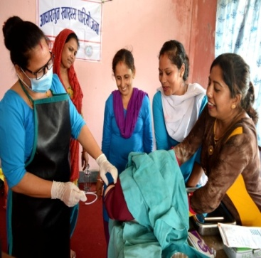
Essential Health Project had organized an 'Onsite Coaching to both SBA & Non-SBA ANM' at Krishnanagar HP of Krishnanagar Municipality. Total 4 ANM participated in the coaching for 3 days. Kalpana Khanal, a Master mentor for onsite coaching, was mentoring the whole program.
On the behalf of all participants, Banina Sen, a Senior ANM, said, "I learned many new things in these 3 days period that I never learnt during my 20 years service period of ANM & 7 Years of SBA ANM. I knew the importance of many minor things during delivery process that I used to ignore. The 3 days onsite coaching organized by Kalika Self reliance Social Center and Fairmed through Essential Health Project had provided us a great opportunity to put our focus on minor things which are very important as well as many new things for us. We never received such kind of onsite coaching in our service period and I feel that I have achieved a great thing after receiving this coaching. I have no idea about such type of training and coaching. Essential Health project made it possible to enhance our skill so, I and y whole team want to thank the EHP team for providing us this opportunity."

