Knowledge is not enough, if not applied the knowledge in self behavior it can create problem to us
Urmila Kori, a 21 years recently married woman, lives with 10 family members in Katuwa, Bijaynagar Rural Municipality ward-5. She belongs to a middle class family and her husband has gone abroad for income generation. She is literate and handling her household normally.
Urmala's life was going normally and after few period of marriage she got pregnant and this news made her as well as entire family happy. She used to spend her time in her house as well as her mother's house. One day Urmila saw a patch on her left hand which was totally different as its color was lighter than normal skin color and it was sense less. Then she remembered her elder sister at her home who was taking medicines of leprosy. She was afraid because she was known about the disease as her sister was cured after regular medication of leprosy. Immediately after the suspect she went to Khururiya health post for check up. Due to unavailability of trained staff in health post, clear diagnosis was not done. She was shared that the next day specialist team of health workers on skin diseases are visiting the site so, she visited next day for her checkup. Doctors thoroughly checked her and diagnosed her as leprosy (PB) and recommended her for 6 month medication. When Urmila knew this she become tensed and immediately replied," Sir, I am 3 Month pregnant and my baby is growing, should I take this medicine or not? Can this harm my baby?" Doctor made her clear that this medicine doesnot harm her baby and it will be safe for both mother and child. Then, Urmila was confident and started medicine from the health post.
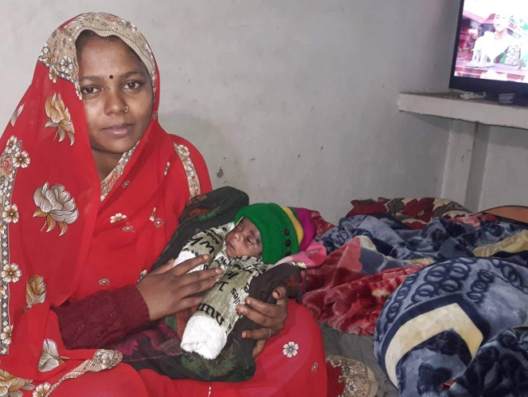
Urmila continued her medicine for 3 months and she felt some stomach aches after medication due to which she left taking the medicines without consultation of health workers. She was regularly doing her ANC visits at health facility and no health worker followed up her regarding the leprosy medication neither she told. The time for delivery arrived and she was facing her labor pain for 2 days. The labor pain started on Friday and still going on Saturday. She thought that health facility will be closed as it is Saturday so her family including her didn't take her to health post. When her labor pain increased, her family decided to take her Chandrauta and they hired a tractor of nearby neighbor and started their journey. As she was bearing the labor pain since 2 days and it was late so, on the way to Chandrauta she gave birth to her child on Tractor. Her family members stayed there for some time and took her back to home as they saw mother and baby healthy. Now, Child & Mother are at good health condition.
Urmila said, "I always tried my best to care my child and my heath. I always went to HP for ANC, but health post sister was not interested to do my check up neither interested to give medicines. She never gave advice for care of baby and me. I was unaware about the system of HP. So, my baby was born on a tractor." She further added her feeling with thankfulness to Devu KC, CHM, for reminding me and supporting, "I stopped taking medicine of leprosy due my worst health condition. Now, I will visit HP and bring medicine & will re-continue my medicines. Now, I also realized that birth preparedness plan is important and it should be done during pregnancy period."
Urmila is a leprosy affected mother and now she is taking medicine and encouraging her neighbor for institutional delivery in nearby birthing center. She also promised to support to enroll leprosy affected people for medication.

