Change seen in Health Mother's Group after SATH tool endorsement
Female Community Health Volunteers (FCHVs) formed a Mother group named as Health Mother Group and has to conduct monthly meeting and discuss on major health issues of that community. The concept is to aware mothers of community about the health more focusing on maternal and child health. But the situation of current health mothers group is worse in many areas as they are rarely conducting meeting, focusing on fund collection and rare discussion on health issues.
One of the health mother groups in Ramuhadaha of Shivagadi has the similar conduction. There are 35 members in the group and the group is named as Shivagadi Health Mother's Group. The member in the group rarely got together for meeting usually 1000days mothers used to be absent on the meeting and they used to collect fund and return home without any discussion on health topics. Only in few cases when someone outsider visited or someone in group has some concern on health discussion on health was done.
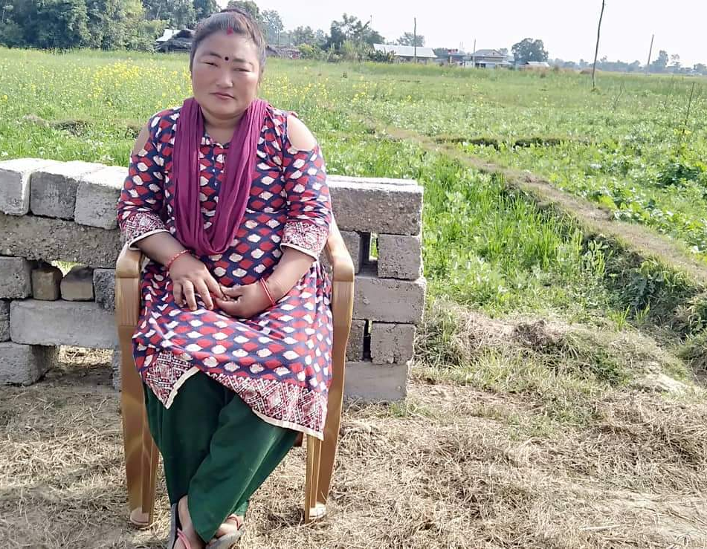
Essential health Project supported to endorse SATH Tool (Self-Applied Technique for Quality Health) in this Mother group on 2076/05/10 which has contributed in bring some effectiveness in the group. Now, pregnant women, recently delivered mother, 1000 days mothers, their mother in-laws participate in meeting actively. Now-a-days meeting is conducted regualy. Members of this group call this tool as 'Tika Karyakram' and showed their excitement while putting tika on their house on map. Different health issues like importance of 4 ANCs, PNC, Institutional delivery, immunization of child, care of newborn, leprosy, filarial etc are discussed in the meeting while ensuring the indicators in map. Necessary counseling and recommendation were also done by FCHV as per need. "We just thought that group was establish to collect fund and take loan, we were busy and never thought the importance of meeting and health issues so, we seldom come in meeting. 'Tika Karyakram' teaches us about the importance of 4 ANC, PNC and Institutional delivery, Immunization,etc. It also encouraged and motivated us to participate in our monthly meeting. now we all regularly come in meeting and I personally call members to participate in our meeting." Said Shivagadi Health Mother Group Chairperson Anita Roka.
Anita Roka
Chairperson, Shivagadi HMG-Shivagadi
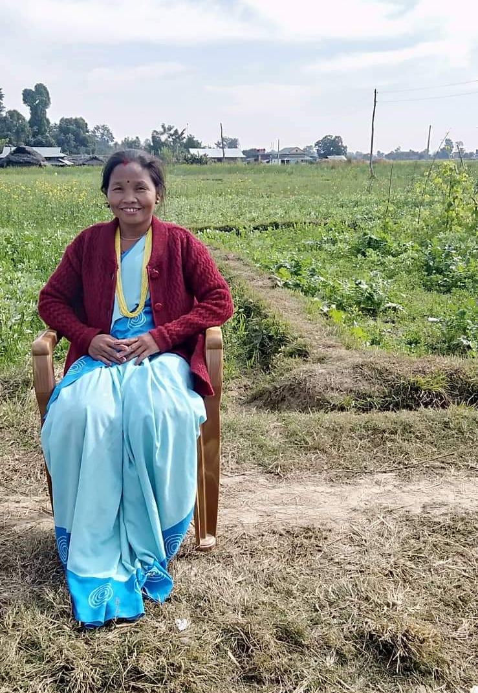
FCHV Manju Gharti also told," It was difficult for me to gather people for meeting and discuss on health topic so, I have to visit each house for counseling and ensure the ANC, Vaccine coverage, etc in community. But, after the tika Karyakram, it has made my work easier as mothers participate in the meeting and we together discuss on topics like ANC, Immunization, home delivery effects, etc during the meeting and I also provide request support to members. I would like to Thank Manju Sister, CHM of EHP as she is regularly supporting me for regularization and empowering our community."
Community need a spark to bring a flam and SATH tool has worked as spark to empower and regularize the meeting of Health Mothers Group. The effectiveness of the tool can be observed when the members of group regularly come and discuss during their monthly meeting.
Manju Gharti
FCHV, Shivagadi

